Software Requirements Specification

for

SonicFM

Version 1.0

Prepared by

Group Name: <*place your group name here*>

|  |  |  |
| --- | --- | --- |
| Arnav Mejari | 60004210199 | [arnavmejari@gmail.com](mailto:arnavmejari@gmail.com) |
| Darsh Jain | 60004210200 | <e-mail> |
| Atharva Desai | 60004210204 | [desaiatharva50@gmail.com](mailto:desaiatharva50@gmail.com) |
|  |  |  |
|  |  |  |

|  |  |
| --- | --- |
| Instructor: | Dr. Kiran Bhowmick |
| Course: | Software Engineering |
| Lab Section: |  |
| Teaching Assistant: | *N.A.* |
| Date: | 11/2/24 |

Contents

Revisions ii

1 Introduction 3

1.1 Document Purpose 3

1.2 Product Scope 3

1.3 Intended Audience and Document Overview 3

1.4 Definitions, Acronyms and Abbreviations 3

1.5 Document Conventions 4

1.6 References and Acknowledgments 4

2 Overall Description 5

2.1 Product Perspective 5

2.2 Product Functionality 5

2.3 Users and Characteristics 6

2.4 Operating Environment 7

2.5 Design and Implementation Constraints 7

2.6 User Documentation 8

2.7 Assumptions and Dependencies 8

3 Specific Requirements 10

3.1 External Interface Requirements 10

3.2 Functional Requirements 11

3.3 Behaviour Requirements 13

4 Other Non-functional Requirements 14

4.1 Performance Requirements 14

4.2 Safety and Security Requirements 14

4.3 Software Quality Attributes 14

Appendix A – Data Dictionary 15

Revisions

| Version | Primary Author(s) | Description of Version | Date Completed |
| --- | --- | --- | --- |
| 1.0 | Arnav Mejari, Darsh Jain, Atharva Desai | Complete requirements for the SonicFM Software project. | 20/02/24 |

# 

# Introduction

## Document Purpose

This Software Requirements Specification (SRS) serves as a comprehensive guide for SonicFM version 1.0, our inaugural release of the music streaming platform. SonicFM aims to replicate the popular features of platforms like Napster, Wynk, etc. offering users an extensive library of music, the ability to create personalised playlists, and tools for social sharing.

The document provides detailed insights into SonicFM's essential functionalities, system architecture, and external interfaces. It is intended to ensure clear communication among development teams, stakeholders, and other involved parties, guaranteeing that the platform aligns with project objectives and delivers a seamless user experience. By outlining requirements within a single system, this SRS lays the groundwork for SonicFM's successful development, launch, and ongoing improvement.

## Product Scope

SonicFM is an innovative music streaming platform that aims to transform how users explore, enjoy, and exchange music. Our main goal is to deliver a seamless and tailored listening experience, granting users access to a wide selection of songs spanning various genres and artists. Through SonicFM, users can effortlessly craft personalised playlists, discover handpicked recommendations, and connect with friends to share beloved tracks.

Our platform is dedicated to simplifying music discovery, encouraging user interaction, and nurturing a lively community of music lovers. Furthermore, we endeavour to simplify music consumption by eliminating obstacles, leveraging sophisticated algorithms to offer personalised suggestions, fostering social engagement via playlist sharing, and ensuring fair compensation for artists and creators. This emphasis on social collaboration promotes a sense of community and inclusivity while also contributing to the sustainability of the music industry

## Intended Audience and Document Overview

The Software Requirements Specification (SRS) for SonicFM is for everyone involved in making and using the music streaming platform. This includes developers, project managers, marketing staff, users and testers. The document explains what SonicFM will do and how it will work. It's organised in a way that makes it easy to find information. We suggest to start with the introduction and then go to the section pertaining to your expertise to get more detail about what SonicFM will do and what it needs to do it.

For **Developers**, **Section 3 Specific Requirements** will be your next section.

For **Project Managers, Section 2 Overall Description** will be pertinent.

For **Marketing Team, Section 1.1-1.2 & Section 2.1-2.3** can be used it to understand the features they'll be promoting.

## Definitions, Acronyms and Abbreviations

API Application Program Interface

GDPR: General Data Protection Regulation.

GUI: Graphical User Interface.

HTTP: Hypertext Transfer Protocol.

HTTPS: Hypertext Transfer Protocol Secure.

iOS: iPhone Operating System.

MacOS: Macintosh Operating System.

OAuth: Open Authorization

## Document Conventions

In general this document follows the IEEE formatting requirements. Use Arial font size 11, or 12 throughout the document for text. Use italics for comments. Document text should be single spaced and maintain the 1” margins found in this template. For Section and Subsection titles please follow the template.

## References and Acknowledgments

[1] J. Seo et al. Software Requirements Document for OneMusic https://seniord.cs.iastate.edu/2020-May-02/files/inline-files/SRS%20Template.docx.pdf

[2] D. Vicory et al. Formatting improvements, modifications to user interface, more possible use cases added https://capstone.cs.ucsb.edu/team_docs_14/SRS/SRS_NP_Compete.pdf

# Overall Description

## Product Perspective

SonicFM is a digital music streaming service that provides users with instant access to a vast online library of music and podcasts. It is one of the largest music streaming service providers, with over 590 million monthly active users, including 226 million paying subscribers, as of September 2023. Founded in 2006 by Daniel Ek and Martin Lorentzon, SonicFM has become one of the largest music streaming platforms, with over 551 million users and more than 220 million subscribers. Before SonicFM's dominance in the music streaming industry, several platforms like Napster, iTunes, Pandora, Last.fm, Rhapsody, Deezer, Grooveshark, and Rdio shaped the digital music landscape. Napster faced legal challenges due to copyright violation, iTunes revolutionised digital music sales, Pandora introduced personalised radio, and Last.fm combined streaming with social features. Rhapsody pioneered subscription-based streaming, while Deezer offered a freemium model. Grooveshark's free music-sharing model led to legal issues, and Rdio faced bankruptcy. SonicFM emerged as a comprehensive replacement, combining streaming, social elements, and a vast catalogue, ultimately becoming the go-to platform for music enthusiasts worldwide. Its success lay in addressing the limitations and legal challenges faced by its predecessors, offering a seamless and legal music streaming experience.

## Product Functionality

SonicFM's core feature is its extensive music streaming service, providing users access to a vast library of songs, albums, and playlists across various genres.

The global popularity of this music platform can be attributed to its wide usage, driven by a set of core features:

* **Music, Podcasts & Playlists:** SonicFM offers a diverse range of content, including music, podcasts, and customizable playlists.
* **Recommendations**: Enjoy tailored music suggestions based on your listening history and preferences.
* **Personalized Playlists**: Curate and discover playlists personalized to your taste and mood.
* **Device Compatibility:** Access SonicFM seamlessly across a variety of devices for a consistent and flexible listening experience.
* **Premium Subscription:** Unlock additional features and an ad-free experience with SonicFM's premium subscription.
* **Social Sharing:** Share your favorite tracks, playlists, and listening experiences with friends on social media.
* **Artist Discovery:** Explore new artists and genres with features designed to enhance your music discovery experience.
* **High-Quality Audio**: Enjoy superior sound quality with SonicFM's support for high-fidelity audio.
* **Download Music (Premium Users):** Premium subscribers can download their favorite music for offline listening, providing flexibility and convenience.

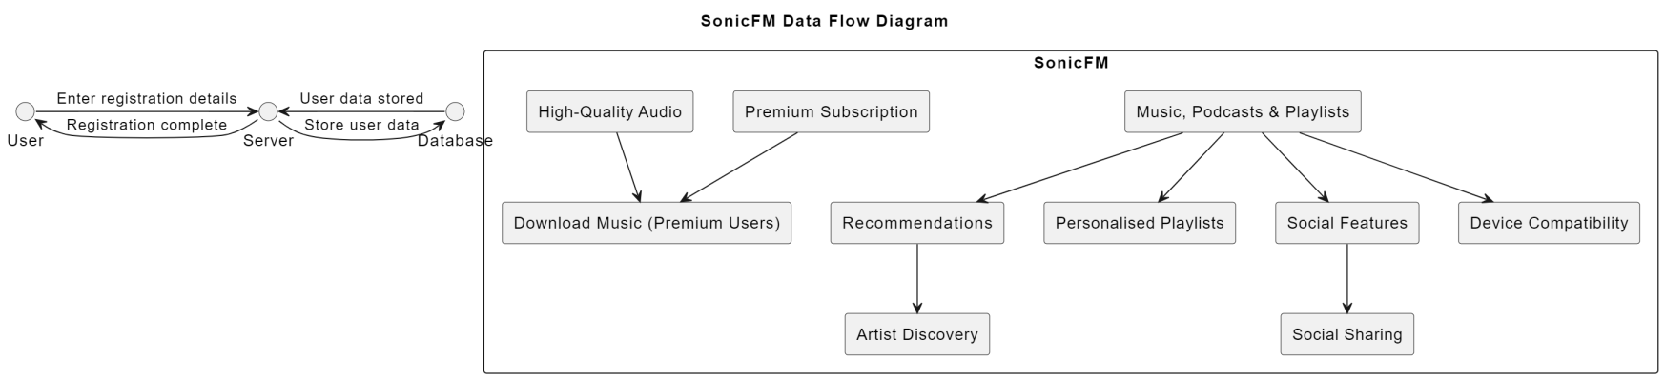

## Users and Characteristics

**Following are the typical SonicFM users:**  
  
**1) Casual Listeners:**

Casual listeners enjoy music occasionally, with diverse tastes and a less frequent engagement with advanced features. They seek an intuitive interface for easy navigation, straightforward playlist creation, and access to a wide variety of music genres, prioritizing simplicity in their user experience.

**2) Dedicated Music Enthusiasts:**

Dedicated enthusiasts actively engage with SonicFM, curating extensive playlists and regularly exploring new artists and genres. They require advanced playlist management, personalized recommendations, access to a vast music library, and features facilitating the discovery of fresh music to satisfy their deep interest and involvement in the platform.

**Distinguishing Important Users:**

* For SonicFM, the most important users are likely to be the Dedicated Music Enthusiasts and the Technical Experts. These users drive engagement, contribute to the platform's content, and may appreciate and utilize advanced features.
* Casual Listeners are also crucial for user base expansion, but their requirements might be less complex.
* While other user categories are essential, the platform's focus should be on delivering an exceptional experience for those who actively engage with and contribute to the musical ecosystem.

## Operating Environment

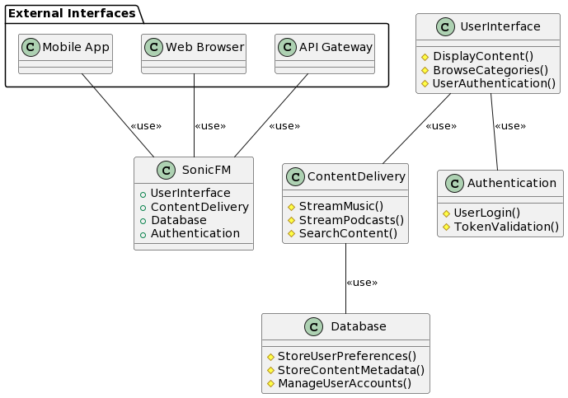SonicFM is designed to operate in a dynamic and diverse digital environment, accommodating a wide range of hardware and software configurations to ensure accessibility for a broad user base. The software is intended to be compatible with major operating systems, including Windows, macOS, and various Linux distributions. It should seamlessly integrate with popular web browsers like Google Chrome, Mozilla Firefox, and Safari, providing users with flexibility in their choice of access. SonicFM aims to coexist harmoniously with a variety of hardware platforms, ranging from standard laptops and desktops to mobile devices like smartphones and tablets. The minimum platform requirements for SonicFM would likely include a reasonably modern computer or mobile device with an internet connection, ensuring accessibility for a large user demographic. Additionally, compatibility with popular music playback devices and smart speakers is considered, enhancing the versatility of the SonicFM experience across various user setups.

## Design and Implementation Constraints

Constraints for the SonicFM platform can arise from various factors, including the nature of the product and the expectations of the users.

1. **Streaming Technology Compatibility:**

SonicFM involves streaming music and podcasts. Developers must ensure compatibility with various devices, operating systems, and network conditions. Limitations in certain devices or older technologies might affect the seamless streaming experience.

1. **Data Security and Privacy Compliance:**

Given that SonicFM deals with user accounts and preferences, the development team must adhere to strict data security and privacy standards. Compliance with regulations such as GDPR or other regional data protection laws might impose constraints on data handling and storage practices.

1. **Content Licensing and Copyright Regulations:**

Developers must comply with licensing agreements and copyright regulations for the music and podcast content available on SonicFM. This involves restrictions on the types of content that can be offered, geographic limitations, and ensuring proper royalty payments to content creators.

1. **Cross-Platform Compatibility:**

SonicFM aims to provide a user interface through both mobile apps and web browsers. Developers must address challenges related to different screen sizes, resolutions, and input methods. Ensuring a consistent user experience across various platforms can be a constraint.

1. **Network Bandwidth and Speed:**

The success of SonicFM heavily relies on the ability to deliver high-quality audio content seamlessly. Developers need to consider limitations in network bandwidth and speed, especially in regions with slower internet connections. This could impact the quality of streaming and user satisfaction.

These constraints will influence the architectural and design decisions made during the development of SonicFM, requiring careful consideration to meet user expectations and industry standards.

## User Documentation

User documentation will encompass essential components to facilitate a seamless and user-friendly experience. A comprehensive user manual will be developed, covering topics such as account setup, navigation within the platform, playlist creation, and personalized settings. Clear instructions on using features like content search, streaming music, and podcast playback will be provided. Additionally, an online help system will be integrated into the platform, offering contextual guidance and quick answers to user queries. Tutorials, in the form of interactive guides or video demonstrations, will be included to assist users in maximizing the platform's capabilities. The documentation will be delivered in easily accessible digital formats, ensuring compatibility with various devices and user preferences. Adherence to industry standards for user documentation will be prioritized, promoting clarity, consistency, and user empowerment in navigating and enjoying the SonicFM platform.

## Assumptions and Dependencies

Several assumptions may impact the requirements outlined in the SonicFM Software Requirements Specification (SRS):

**Content Licensing Agreements:**

It is assumed that the necessary licensing agreements for music and podcast content are obtained legally and adhere to industry standards. Failure to secure proper licensing may result in limitations on the available content and could necessitate alterations to the platform's features and offerings.

**Third-Party API Stability:**

The successful integration of third-party APIs for features like content recommendations and social media sharing is assumed to be reliable and stable. Any unforeseen changes or disruptions in these external services may require adjustments to maintain the intended functionality of SonicFM.

**Internet Connectivity for Users:**

SonicFM relies on users having consistent internet connectivity for content streaming. It is assumed that users will have reliable internet access, and any deviations from this assumption may impact the user experience, potentially requiring offline features or alternative streaming solutions.

**Device and Platform Updates:**

Users are expected to keep their devices and platforms (e.g., mobile apps, and web browsers) updated to the latest versions. Assumptions regarding user device capabilities and software updates may affect the compatibility and performance of SonicFM, requiring periodic assessments and adjustments.

**Compliance with Privacy Regulations:**

SonicFM assumes that user data handling and privacy practices align with existing and evolving regulations. Any changes in privacy laws or unexpected legal developments may necessitate modifications to the platform's data management and security measures.

These assumptions highlight potential areas of uncertainty that could influence the development and operational aspects of SonicFM. Regular monitoring and communication with relevant stakeholders are crucial to address any discrepancies and ensure the successful implementation of the platform.

# Specific Requirements

## External Interface Requirements

### User Interfaces

The user interface shall consist of three different GUI screens. They are Home Page, Explore Tab and Personal Library. All interfaces have the bottom taskbar and song display as well as profile in the top left common while internal items change accordingly.

**3.1.1.1 Home Page**

The Home page serves as the main landing page for the software. This includes a blend of items from personal library, recent listen as well as recommendations from the backend.

**3.1.1.2 Explore/Search Tab**

Search tab allows users to explore and discover music, podcasts, and other audio content. Users can enter keywords, such as artists, albums, or genres, in the search bar to find specific content or explore recommendations. The Search tab typically provides relevant results and suggestions based on user input, helping them easily navigate and discover a wide range of audio content available on the SonicFM platform.

**3.1.1.3 Your Library**

The "Your Library" tab in the SonicFM app serves as a personalized collection of the user's saved and downloaded content. This includes saved songs, albums, playlists, and podcasts. Users can organize their music and audio content within this tab, making it easy to access and manage their favorite tracks and collections. The tab often includes subsections like "Liked Songs," "Playlists," and "Albums" to help users navigate and find specific content.

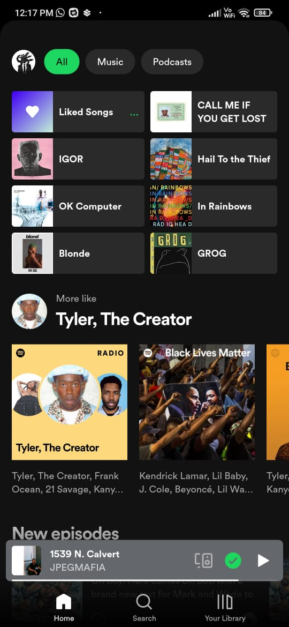 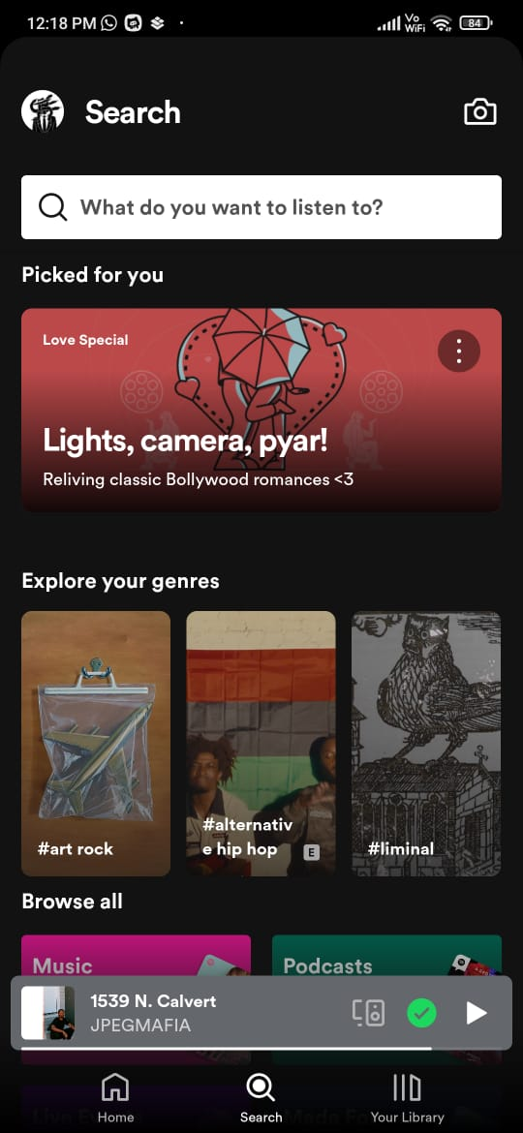 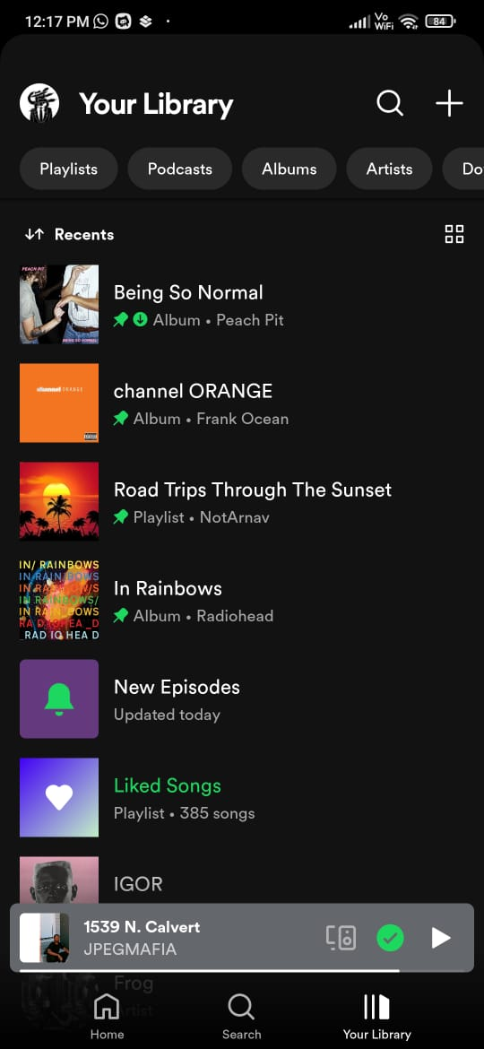

3.1.1.1 Home Page 3.1.1.2 Search Tab 3.1.1.3 Your Library

### Hardware Interfaces

**3.1.2.1 Touchscreen Interface:** On mobile devices, such as smartphones and tablets, users interact with the Spotify app through touchscreens. They can navigate through menus, play/pause songs, and manage playlists using touch gestures.

**3.1.2.2 Buttons and Controls:** On various devices, including smartphones, tablets, and smartwatches, physical buttons and controls (e.g., play, pause, skip, and volume buttons) are used to manage playback without directly interacting with the touchscreen.

### Software Interfaces

**3.1.3.1 Operating System APIs:** The app interacts with operating system APIs to perform tasks specific to the platform it's running on. This includes interfacing with iOS or Android APIs on mobile devices.

**3.1.3.2 Web APIs:** SonicFM provides Web APIs that allow third-party developers to integrate with the platform. This includes features like accessing user playlists, searching for music, and retrieving metadata about songs and artists.

**3.1.3.3 Networking APIs:** The app relies on networking APIs to communicate with our servers. This includes sending and receiving data related to user authentication, playlists, music streaming, playing ads,etc.

### Communications Interfaces

**3.1.4.1 OAuth for Authentication:** SonicFM uses OAuth (Open Authorization) for user authentication. This involves a secure and standardized authorization protocol that allows the app to access a user's account without exposing the user's credentials.

**3.1.4.2 Internet Communication:** The app relies on internet communication to connect with its servers for tasks such as streaming music, syncing playlists, and updating content. This involves the use of standard internet protocols such as HTTP/HTTPS for data transfer. The SonicFM app uses streaming protocols to deliver music content efficiently over the internet. These protocols enable the app to stream audio data in real-time, providing a seamless listening experience.

## Functional Requirements

**1. Music, Podcasts & Playlists Recommendations:**

* **User Profile Analysis:** - The system shall continuously analyze the user's listening history, including played songs, skipped tracks, and user-generated playlists. - Algorithms shall be employed to generate real-time music and podcast recommendations based on the user's preferences and historical data.
* **Dynamic Recommendation Updates:** - The recommendation engine shall dynamically update suggestions as the user interacts with the app, incorporating real-time feedback and content availability.

**2. Personalized Playlists:**

* **User-Curated Playlists:** - Users shall have the ability to create and curate playlists based on their music preferences, moods, and themes. - The system shall provide tools for users to add, remove, and rearrange songs within their playlists.
* **Algorithmic Playlist Suggestions:** - SonicFM shall employ algorithms to suggest and generate playlists automatically, considering user behavior, preferences, and current music trends.

**3. Device Compatibility:**

* **Cross-Platform Access:** - The app shall be accessible seamlessly across various devices, including smartphones, tablets, computers, smart speakers, and other compatible devices. - User preferences and settings shall synchronize across devices for a consistent listening experience.
* **Adaptive User Interface:** - The app's user interface shall adapt to different screen sizes and resolutions, optimizing the user experience for each device type.

**4. Premium Subscription:**

* **Subscription Options:** - Users shall have the option to subscribe to SonicFM's premium service, selecting from different subscription plans. - The system shall provide clear information on premium features, pricing, and billing cycles.
* **Secure Payment Transactions:** - The premium subscription process shall involve secure and encrypted payment transactions, ensuring the confidentiality of user payment information.

**5. Social Sharing:**

* **In-App Sharing Integration:** - Users shall be able to share their favorite tracks, playlists, and listening experiences directly from the app to popular social media platforms. - Customizable sharing options, including personalized messages and visual elements, shall be provided.
* **Cross-Platform Sharing:** - Shared content shall be accessible and playable across various social media platforms, enhancing the reach of shared music and playlists.

**6. Artist Discovery:**

* **Personalized Artist Recommendations:** - The system shall recommend new artists and genres based on the user's listening habits, helping users discover music aligned with their preferences.
* **Genre Exploration Features:** - Features such as genre-based radio stations, curated playlists, and genre-specific charts shall be provided to facilitate user exploration.

**7. High-Quality Audio:**

* **Audio Streaming Quality Control:** - SonicFM shall support user-configurable settings for audio quality, allowing users to choose between standard and high-fidelity streaming.
* **Adaptive Streaming:** - The app shall adapt audio streaming quality based on available network bandwidth to ensure a seamless and high-quality listening experience.

**8. Download Music (Premium Users):**

* **Offline Music Download:** - Premium users shall have the capability to download music for offline playback, with a limit on the number of downloads based on subscription tier. - Downloaded content shall be securely stored within the app, with options for automatic updates.

## Behaviour Requirements

### Use Case View

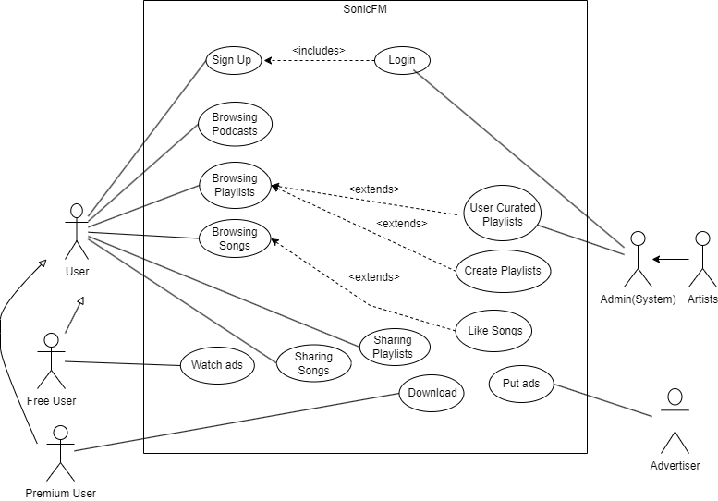

# Other Non-functional Requirements

## Performance Requirements

1) The app will run in the background without consuming too many resources.

2) The app should ensure that music playback actions, such as play, pause, skip, and volume control, are responsive, with a recommended time until action takes effect, about 500 ms for standalone devices and 1000 ms for multi-device systems.

3) The app should support high-quality audio streaming at 320 kbps, and ensure that the audio system does not generate any unwanted noise or glitches.

4) The app should track user listening habits for better prediction of playlists.

5) The song library and playlists should be able to handle more than 100 songs to be stored

## Safety and Security Requirements

**4.2.1 Safety Requirements:**

* **Volume Limitation for Hearing Protection:** The product must include a feature that allows users to set a maximum volume limit to prevent potential hearing damage. This limit should be customizable by users based on their preference, but it should have a default setting in compliance with recognized safety standards for prolonged audio exposure.
* **Driver Mode for Safe Driving:** SonicFM must have a "Driver Mode" that automatically simplifies the user interface, limits interaction, and promotes hands-free operation when the platform detects that the user is in a moving vehicle. This is to ensure distraction-free driving and reduce the risk of accidents caused by interacting with the app while driving.
* **Emergency Notification Override:** The product should be capable of integrating with emergency alert systems to automatically lower or pause the playback in the event of critical alerts, such as severe weather warnings, public safety announcements, or disaster notifications. This ensures that users receive important information without distraction.

**4.2.2 Security Requirements:**

* **Data Encryption:** All user data, including personal information, payment details, and listening history, must be encrypted both in transit and at rest to prevent unauthorized access.
* **Multi-Factor Authentication (MFA):** SonicFM must implement a multi-factor authentication mechanism to enhance user account security, requiring users to verify their identity through at least two different methods, such as a password and a one-time code.
* **Privacy Controls:** Provide users with granular privacy controls, allowing them to manage who can access their listening history, playlists, and other personal information. Transparent privacy policies should be in place, adhering to relevant data protection regulations.

## Software Quality Attributes

**4.3.1 Reliability:** Reliability is a critical quality attribute for SonicFM to ensure a consistent and dependable user experience.

* Availability: SonicFM shall aim for 99.99% uptime, allowing users to access the platform without significant disruptions. This will be achieved through redundant server architecture, automated failover mechanisms, and proactive monitoring to detect and address issues promptly.
* Error Handling: The system shall provide informative and user-friendly error messages, guiding users in the case of unexpected errors. Error logs will be maintained for analysis and continuous improvement of system reliability.

**4.3.2 Usability:** Usability is paramount for customer satisfaction and engagement with the SonicFM platform.

* Intuitive User Interface: The user interface shall be designed following established usability principles, ensuring simplicity, consistency, and intuitiveness. Usability testing will be conducted during development to validate the design choices.
* Personalization Features: SonicFM shall incorporate machine learning algorithms to analyze user preferences and behavior, providing personalized recommendations and playlists, enhancing user engagement and satisfaction.

**4.3.3 Maintainability:** Maintainability is crucial for facilitating future updates, bug fixes, and overall system evolution.

* Modularity and Code Comments: The codebase shall be organized into modular components, each with well-defined functionalities. Additionally, comprehensive comments within the code will be maintained to enhance code readability and ease of understanding for future developers.
* Version Control: SonicFM shall use a version control system (e.g., Git) to manage and track changes systematically. This ensures the ability to revert to previous versions, collaborate effectively, and maintain a stable and evolving codebase.

**4.3.4 Security:** Security is a fundamental attribute, ensuring the protection of user data and system integrity.

* Regular Security Audits: The platform shall undergo regular security audits, including penetration testing and code reviews, to identify and address potential vulnerabilities. This will be conducted at least twice a year to stay ahead of emerging security threats.
* Encrypted Communication: All communication between the SonicFM app and servers shall be encrypted using industry-standard protocols (e.g., TLS). This ensures the confidentiality and integrity of user data during transit.

Appendix A – Data Dictionary

*<Data dictionary is used to track all the different variables, states and functional requirements that you described in your document. Make sure to include the complete list of all constants, state variables (and their possible states), inputs and outputs in a table. In the table, include the description of these items as well as all related operations and requirements.>*